**DESIGN PATTERNS IN JAVA**

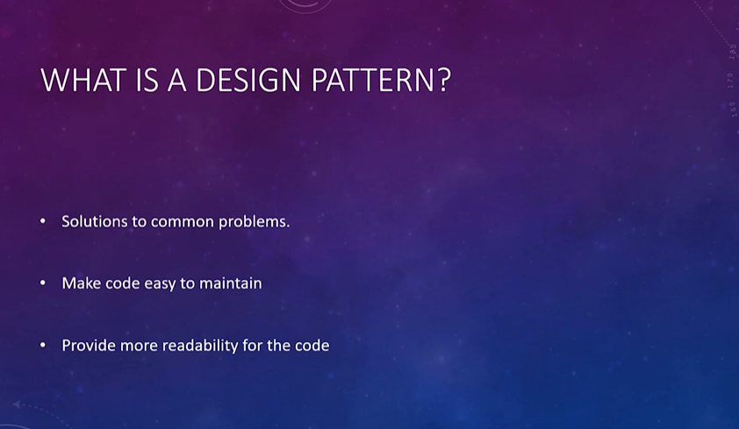

**CREATIONAL PATTERNS**

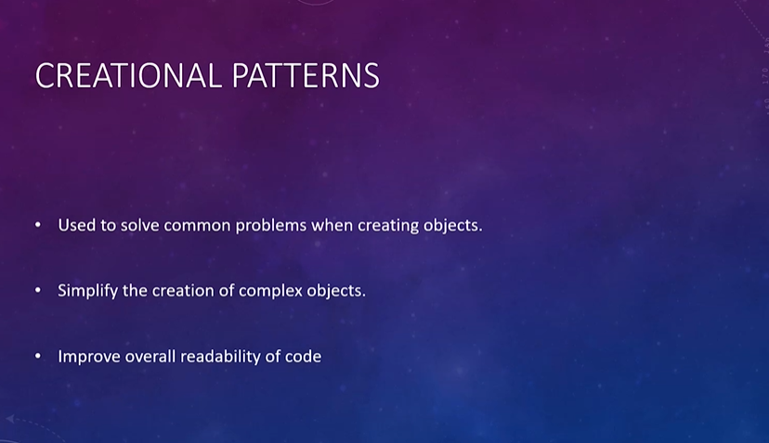





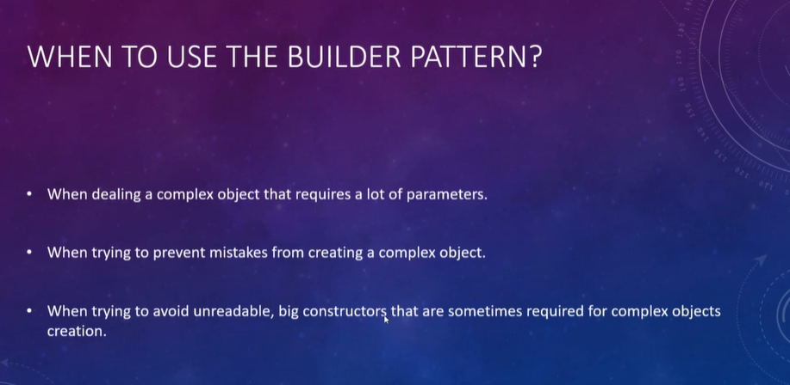

**Problem**

We will use OnlineStoreAccount class with 5 attributes. Let’s create the OnlineStoreAccount class with a constructor with all variable parameters, and with get-set methods.

***OnlineStoreAccount.java***

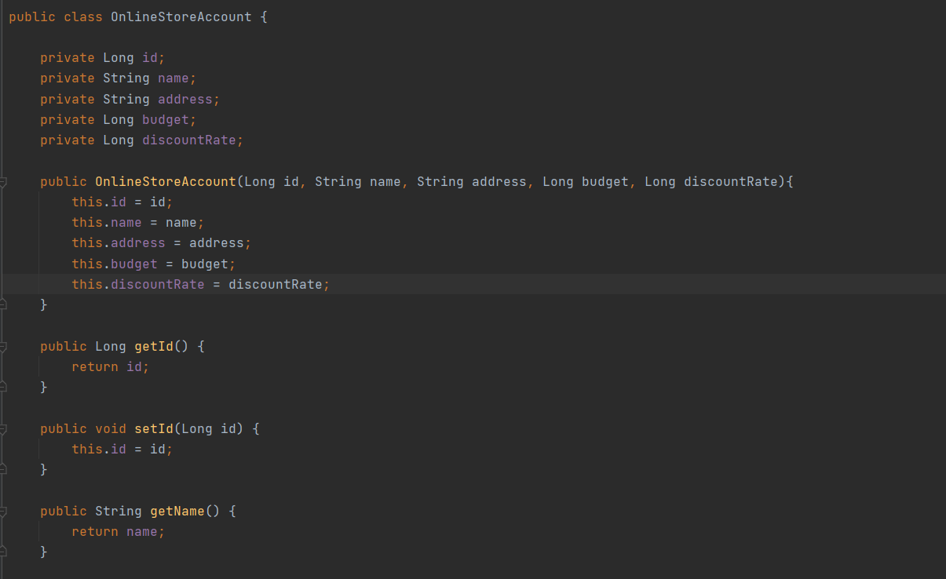

public class OnlineStoreAccount {

private Long id;

private String name;

private String address;

private Long budget;

private Long discountRate;

public OnlineStoreAccount(Long id, String name, String address, Long budget, Long discountRate){

this.id = id;

this.name = name;

this.address = address;

this.budget = budget;

this.discountRate = discountRate;

}

public Long getId() {

return id;

}

public void setId(Long id) {

this.id = id;

}

public String getName() {

return name;

}

public void setName(String name) {

this.name = name;

}

public String getAddress() {

return address;

}

public void setAddress(String address) {

this.address = address;

}

public Long getBudget() {

return budget;

}

public void setBudget(Long budget) {

this.budget = budget;

}

public Long getDiscountRate() {

return discountRate;

}

public void setDiscountRate(Long discountRate) {

this.discountRate = discountRate;

}

}

And let’s use this class.

***App.java***

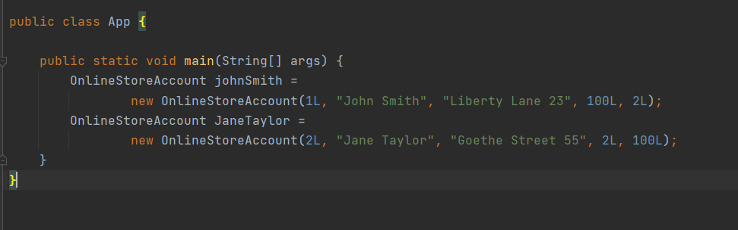

public class App {

public static void main(String[] args) {

OnlineStoreAccount johnSmith =

new OnlineStoreAccount(1L, "John Smith", "Liberty Lane 23", 100L, 2L);

OnlineStoreAccount JaneTaylor =

new OnlineStoreAccount(2L, "Jane Taylor", "Goethe Street 55", 2L, 100L);

}

}

Can you see the problem here with creating objects? Especially the last 2 parameters. Is it easy to understand wcih one is budget, which one is discount rate?

It is very easy to send parameters to the constructor with wrong order.

So, we decided to use Builder pattern here.

We will create the class with variables and get-set methods again.

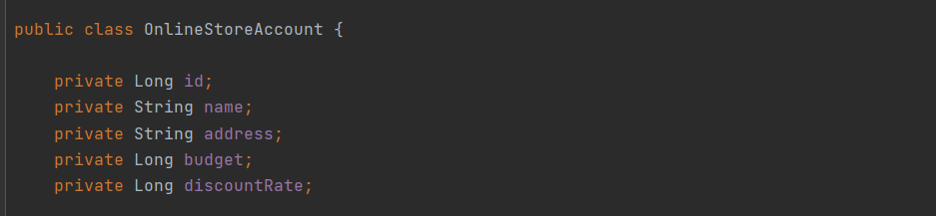

Create a private constructor.

Because we don’t want this class’s objects to be created directly.

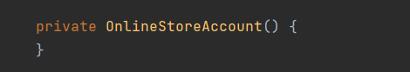

Create an inner static Builder class in this class.

If we have a mandatory variable when creating object from the class, put that variable in the Builder constructor.

And create methods for all other variables to set.

Last, put a build method whose return type is OnlineStoreAccount in the inner static class.

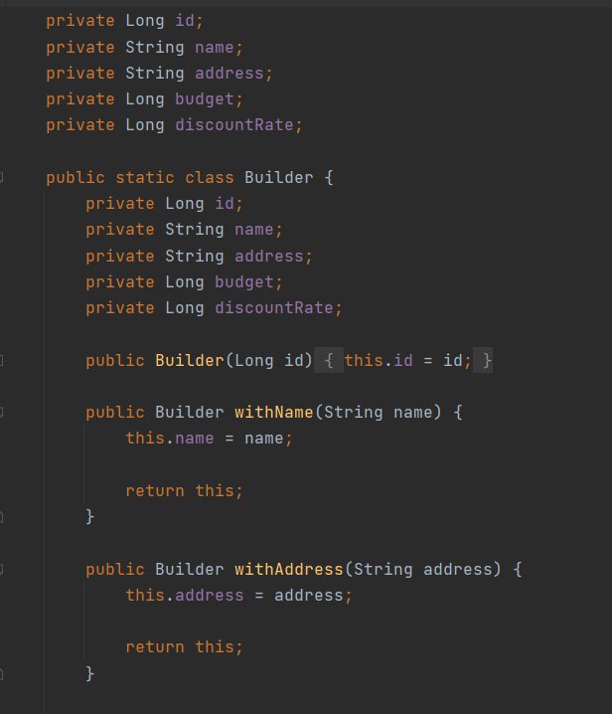

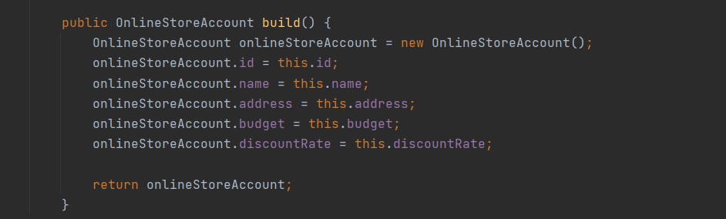

public class OnlineStoreAccount {

private Long id;

private String name;

private String address;

private Long budget;

private Long discountRate;

public static class Builder {

private Long id;

private String name;

private String address;

private Long budget;

private Long discountRate;

public Builder(Long id) {

this.id = id;

}

public Builder withName(String name) {

this.name = name;

return this;

}

public Builder withAddress(String address) {

this.address = address;

return this;

}

public Builder withBudget(Long budget) {

this.budget = budget;

return this;

}

public Builder withDiscount(Long discountRate) {

this.discountRate = discountRate;

return this;

}

public OnlineStoreAccount build() {

OnlineStoreAccount onlineStoreAccount = new OnlineStoreAccount();

onlineStoreAccount.id = this.id;

onlineStoreAccount.name = this.name;

onlineStoreAccount.address = this.address;

onlineStoreAccount.budget = this.budget;

onlineStoreAccount.discountRate = this.discountRate;

return onlineStoreAccount;

}

}

private OnlineStoreAccount() {

}

public Long getId() {

return id;

}

public void setId(Long id) {

this.id = id;

}

public String getName() {

return name;

}

public void setName(String name) {

this.name = name;

}

public String getAddress() {

return address;

}

public void setAddress(String address) {

this.address = address;

}

public Long getBudget() {

return budget;

}

public void setBudget(Long budget) {

this.budget = budget;

}

public Long getDiscountRate() {

return discountRate;

}

public void setDiscountRate(Long discountRate) {

this.discountRate = discountRate;

}

}

Now we can create the App class again.

***App.java***

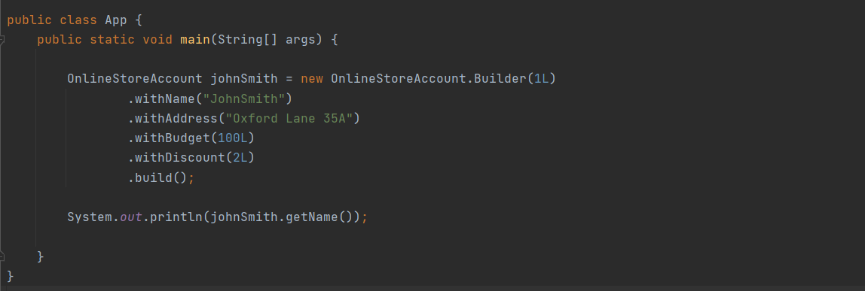

public class App {

public static void main(String[] args) {

OnlineStoreAccount johnSmith = new OnlineStoreAccount.Builder(1L)

.withName("JohnSmith")

.withAddress("Oxford Lane 35A")

.withBudget(100L)

.withDiscount(2L)

.build();

System.out.println(johnSmith.getName());

}

}

As a result, it is more difficult to send the parameters with wrong order, through Builder pattern.

**FACTORY PATTERN**



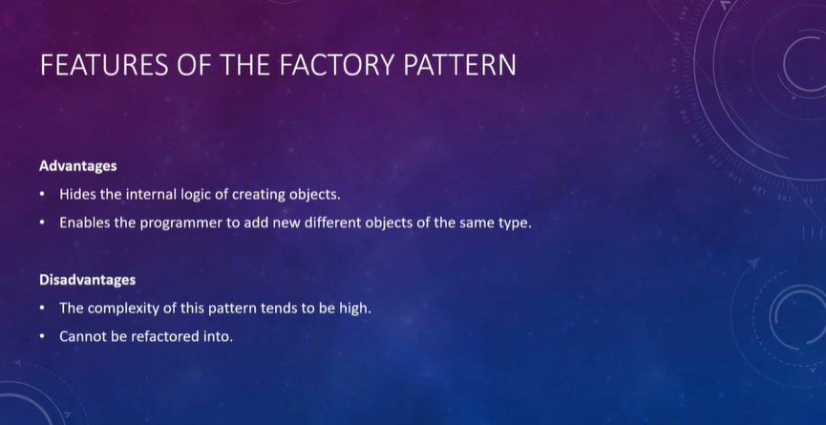

**Problem**

We have a Computer interface and some methods to implement in it.

3 classes (Laptop, Phone, SmartTV) implement that interface.

Our manager wants from us a method that accepts a parameter (“laptop”,”phone”,”smarttv”) and creates object from that class.

We decided to use Factory Pattern to hide implementation details to use the interface methods.

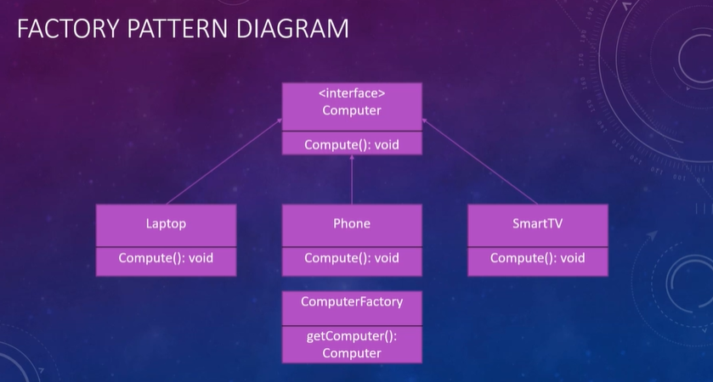

Let's create our *Computer* interface, and *Laptop, Phone, SmartTV, ComputerFactory* classes.

**Computer.java**

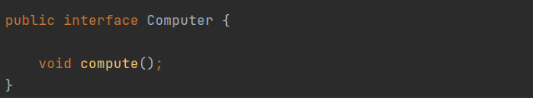

public interface Computer {

void compute();

}

**Laptop.java**

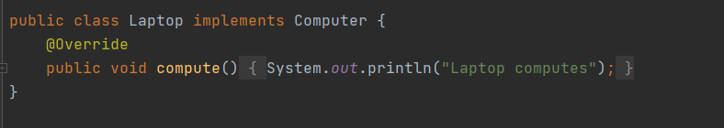

public class Laptop implements Computer {

@Override

public void compute() {

System.out.println("Laptop computes");

}

}

**Phone.java**

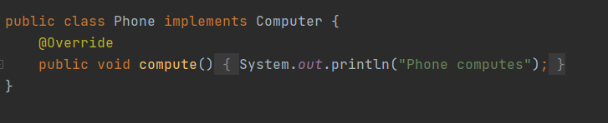

public class Phone implements Computer {

@Override

public void compute() {

System.out.println("Phone computes");

}

}

SmartTV.java

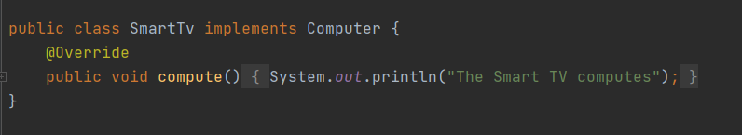

public class SmartTv implements Computer {

@Override

public void compute() {

System.out.println("The Smart TV computes");

}

}

Now we will create a factory class to hide the object instantiation details from the calling function.

**ComputerFactory.java**

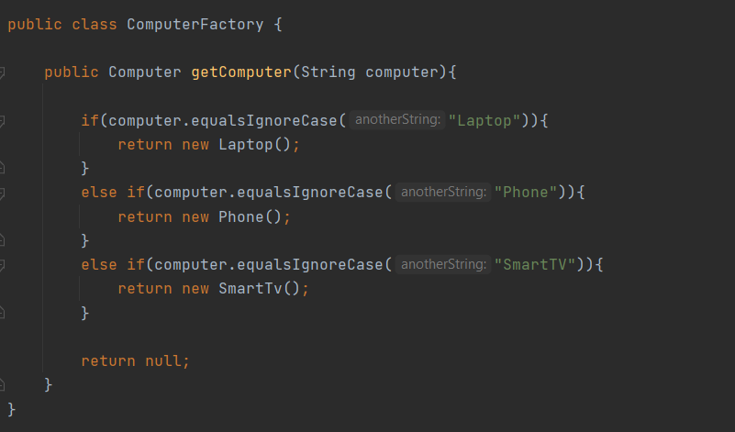

public class ComputerFactory {

public Computer getComputer(String computer){

if(computer.equalsIgnoreCase("Laptop")){

return new Laptop();

}

else if(computer.equalsIgnoreCase("Phone")){

return new Phone();

}

else if(computer.equalsIgnoreCase("SmartTV")){

return new SmartTv();

}

return null;

}

}

When i am writing my app, i only use factory class.

**App.java**

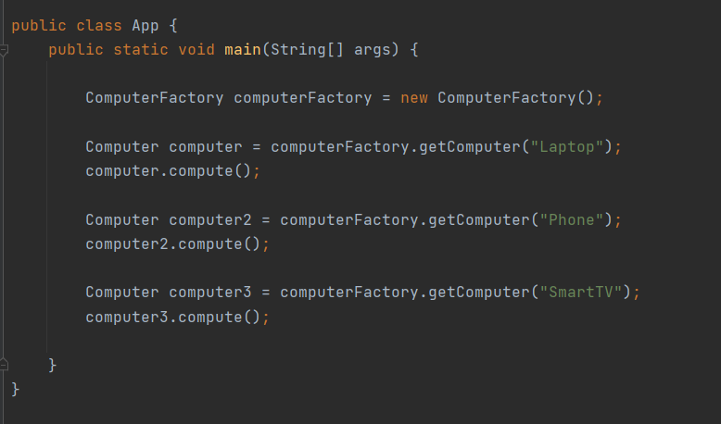

public class App {

public static void main(String[] args) {

ComputerFactory computerFactory = new ComputerFactory();

Computer computer = computerFactory.getComputer("Laptop");

computer.compute();

Computer computer2 = computerFactory.getComputer("Phone");

computer2.compute();

Computer computer3 = computerFactory.getComputer("SmartTV");

computer3.compute();

}

}

**THE ABSTRACT FACTORY PATTERN**



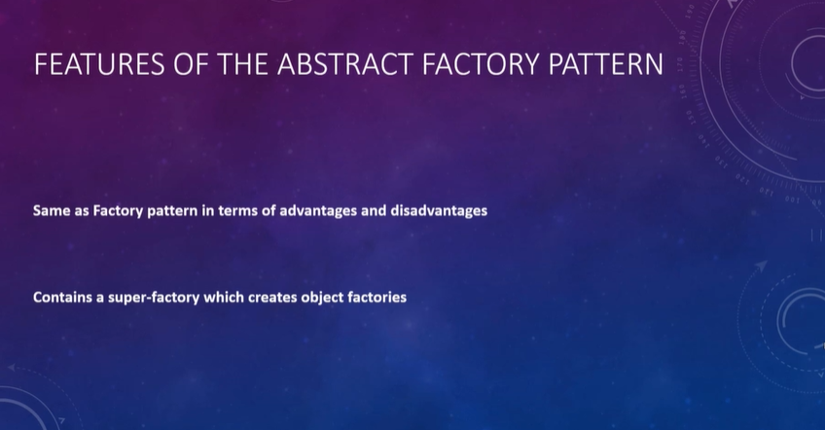

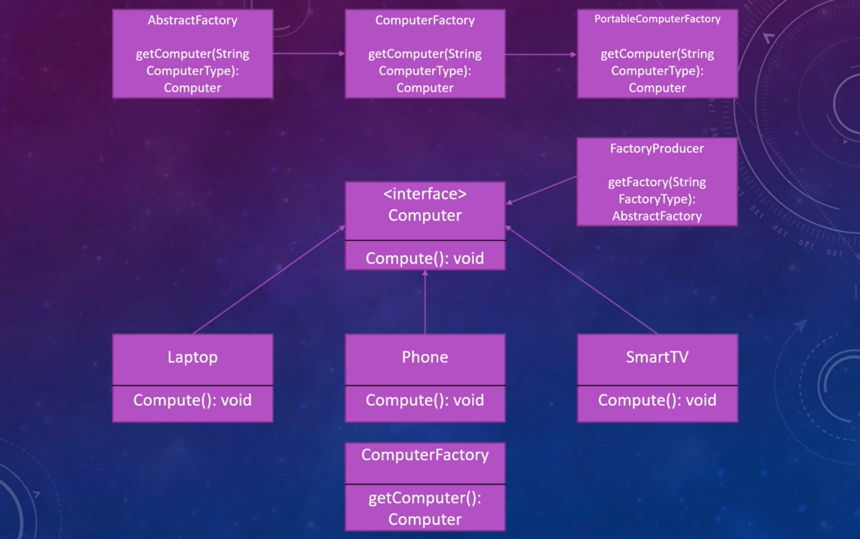

The difference between Factory and Abstract Factory patterns is, we have more than one factory with Abstract Factory pattern.

For Example, ComputerFactory creates all types of computers. PortableFactory creates only portable computers.

FactoryProducer chooses the Factory type.

Let’s create our classes. Phone, Laptop, and SmartTv classes, and the Computer interface are the same with the previous pattern.

First, we’ll create AbstractFactory class.

**AbstractFactory.java**

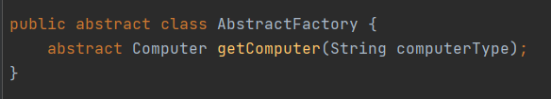

public abstract class AbstractFactory {

abstract Computer getComputer(String computerType);

}

And then, we will create Factory classes. Both of them will extend from AbstractFactory class.

**ComputerFactory.java**

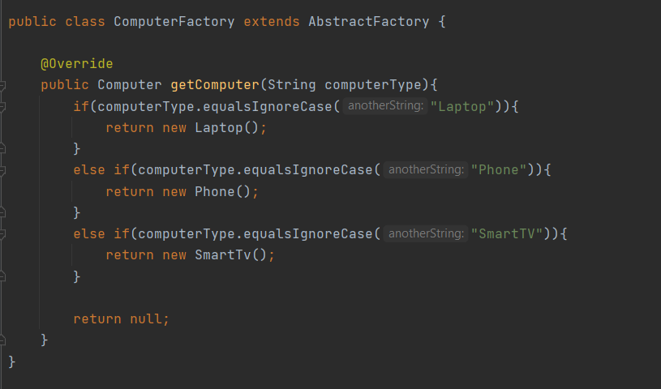

public class ComputerFactory extends AbstractFactory {

@Override

public Computer getComputer(String computerType){

if(computerType.equalsIgnoreCase("Laptop")){

return new Laptop();

}

else if(computerType.equalsIgnoreCase("Phone")){

return new Phone();

}

else if(computerType.equalsIgnoreCase("SmartTV")){

return new SmartTv();

}

return null;

}

}

**PortableComputer.java**

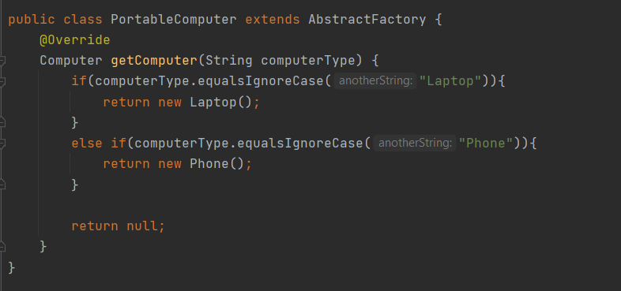

public class PortableComputer extends AbstractFactory {

@Override

Computer getComputer(String computerType) {

if(computerType.equalsIgnoreCase("Laptop")){

return new Laptop();

}

else if(computerType.equalsIgnoreCase("Phone")){

return new Phone();

}

return null;

}

}

Now, create the FactoryProducer class that chooses the Factory class to create.

**FactoryProducer.java**

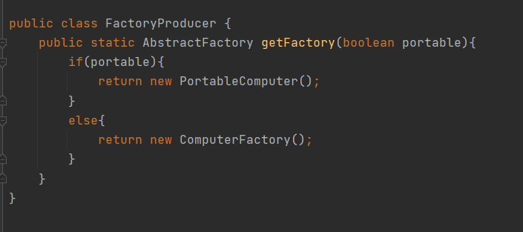

public class FactoryProducer {

public static AbstractFactory getFactory(boolean portable){

if(portable){

return new PortableComputer();

}

else{

return new ComputerFactory();

}

}

}

And run the pattern with the App class.

**App.java**

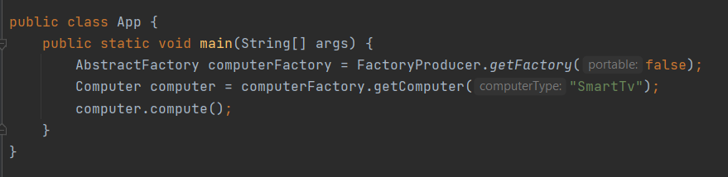

public class App {

public static void main(String[] args) {

AbstractFactory computerFactory = FactoryProducer.getFactory(false);

Computer computer = computerFactory.getComputer("SmartTv");

computer.compute();

}

}

**THE SINGLETON PATTERN**



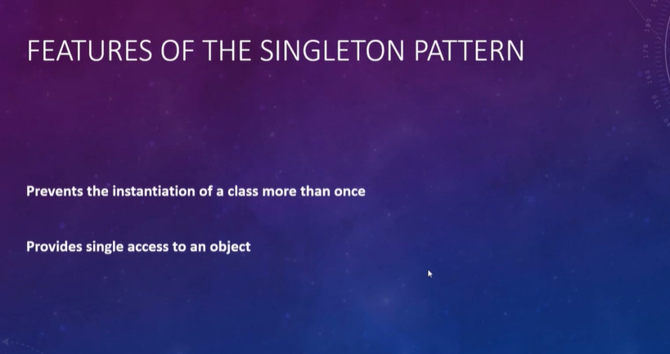



Let’s create our SingletonLogger class.

We will pay attention to the following:

* The constructor will be private. You can’t create an object directly from a singleton class.
* There must be a public static method to get the instance. Method must be lazy loaded. If the object to be returned is null, then create the object.

Also, this method should be thread safe. More than one thread shouldn’t call this method at the same time, so use synchronized keyword.

**SingletonLogger.java**

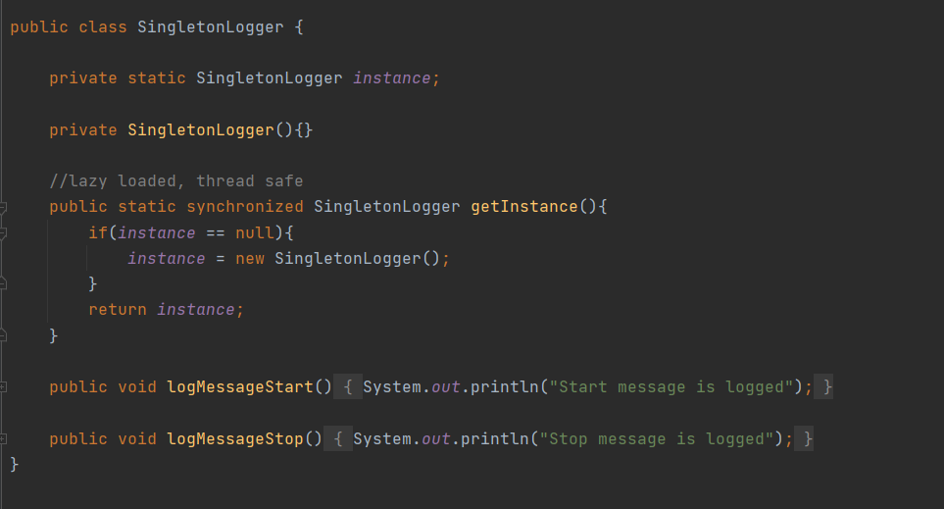

public class SingletonLogger {

private static SingletonLogger instance;

private SingletonLogger(){}

//lazy loaded, thread safe

public static synchronized SingletonLogger getInstance(){

if(instance == null){

instance = new SingletonLogger();

}

return instance;

}

public void logMessageStart() {

System.out.println("Start message is logged");

}

public void logMessageStop() {

System.out.println("Stop message is logged");

}

}

And use the SingletonLogger by calling public static object creation method.

**App.java**

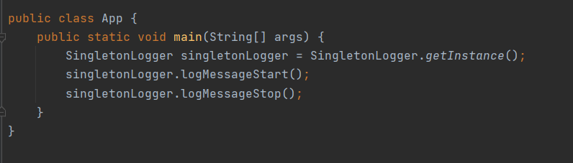

public class App {

public static void main(String[] args) {

SingletonLogger singletonLogger = SingletonLogger.getInstance();

singletonLogger.logMessageStart();

singletonLogger.logMessageStop();

}

}

**THE PROTOTYPE PATTERN**



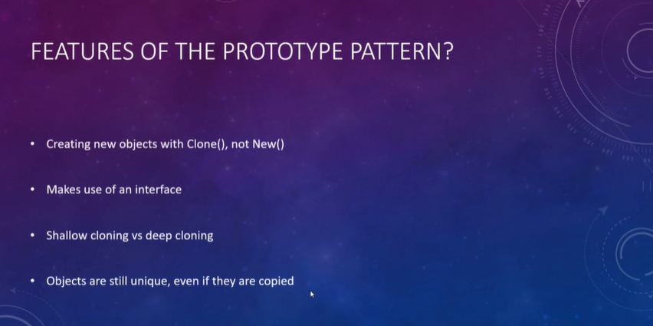

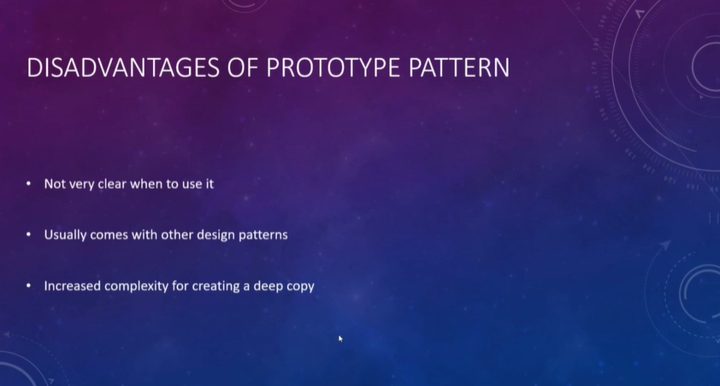

We can use Prototype pattern when it is costly to create an object.

For example, an object can have lots of properties, heavy collections, and other object references in it.

In these situations, we may prefer to clone an object, instead of creating another object.

Pay attention to the following:

* The class of the object to be cloned, should implement Cloneable Interface
* And has a clone method has a return type of the class itself

We will create a Robot class to be cloned, and Components class to referenced by Robot Class.

Components class is a classical POJO.

**Components.java**

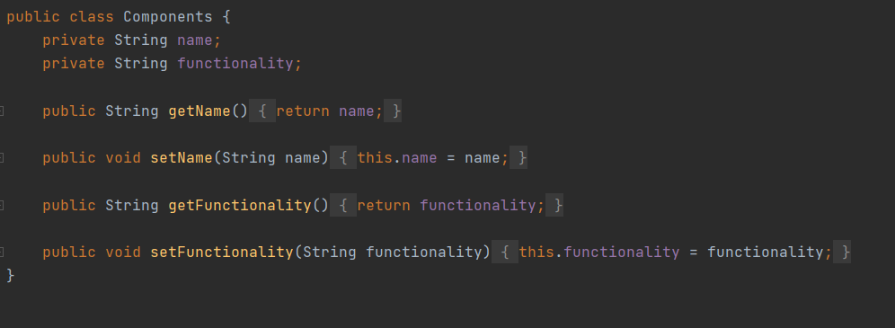

public class Components {

private String name;

private String functionality;

public String getName() {

return name;

}

public void setName(String name) {

this.name = name;

}

public String getFunctionality() {

return functionality;

}

public void setFunctionality(String functionality) {

this.functionality = functionality;

}

}

**Robot.java**

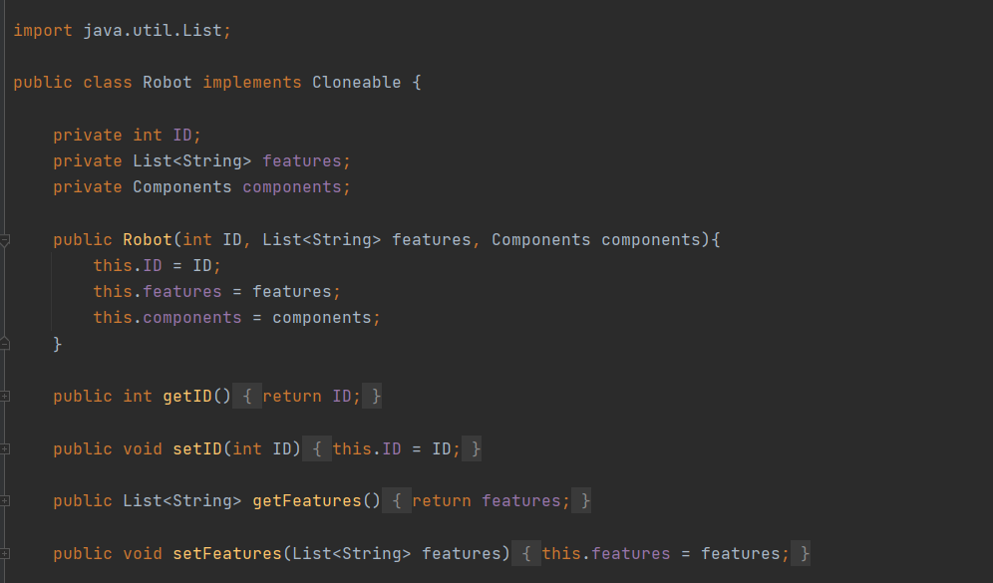

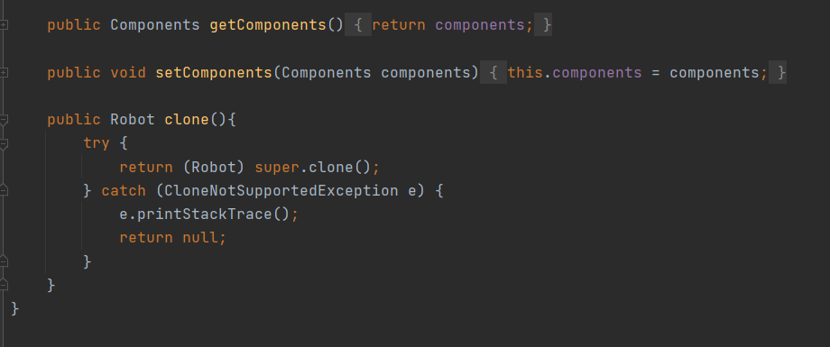

import java.util.List;

public class Robot implements Cloneable {

private int ID;

private List<String> features;

private Components components;

public Robot(int ID, List<String> features, Components components){

this.ID = ID;

this.features = features;

this.components = components;

}

public int getID() {

return ID;

}

public void setID(int ID) {

this.ID = ID;

}

public List<String> getFeatures() {

return features;

}

public void setFeatures(List<String> features) {

this.features = features;

}

public Components getComponents() {

return components;

}

public void setComponents(Components components) {

this.components = components;

}

public Robot clone(){

try {

return (Robot) super.clone();

} catch (CloneNotSupportedException e) {

e.printStackTrace();

return null;

}

}

}

Let’s use Prototype Pattern in App.java

Be careful about that, first object will be created with new keyword, and the others will use clone method to copy from first object.

**App.java**

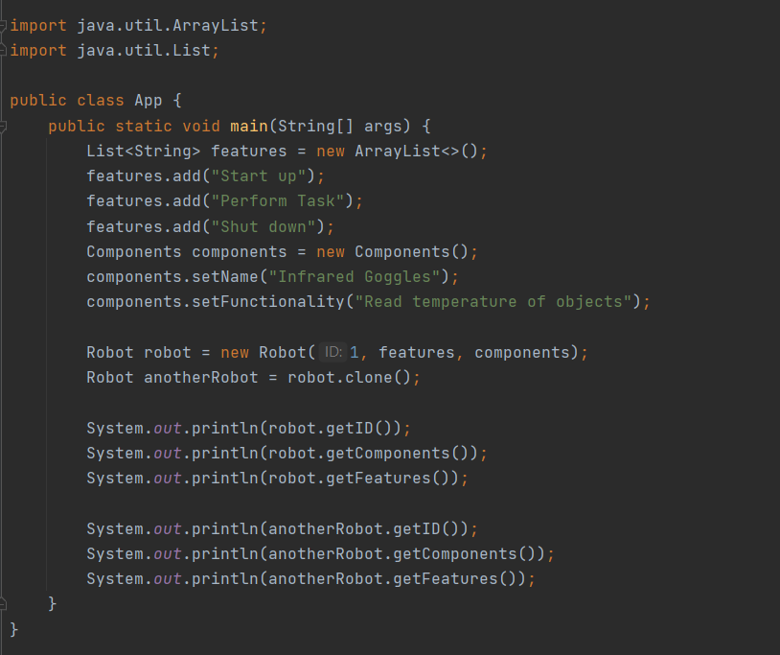

import java.util.ArrayList;

import java.util.List;

public class App {

public static void main(String[] args) {

List<String> features = new ArrayList<>();

features.add("Start up");

features.add("Perform Task");

features.add("Shut down");

Components components = new Components();

components.setName("Infrared Goggles");

components.setFunctionality("Read temperature of objects");

Robot robot = new Robot(1, features, components);

Robot anotherRobot = robot.clone();

System.out.println(robot.getID());

System.out.println(robot.getComponents());

System.out.println(robot.getFeatures());

System.out.println(anotherRobot.getID());

System.out.println(anotherRobot.getComponents());

System.out.println(anotherRobot.getFeatures());

}

}

**THE OBJECT POOL PATTERN**



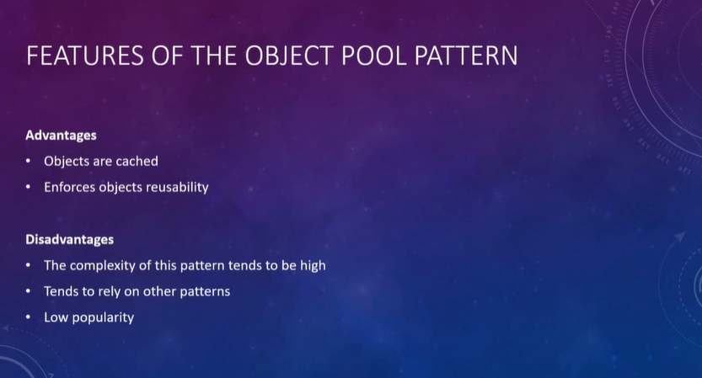

We need a class that has an Hashtable or HashMap in it to be used as pool.

Robot and Components classes are the same classes just like in prototype pattern.

We will need an abstract class ObjectPool first.

**ObjectPool.java**

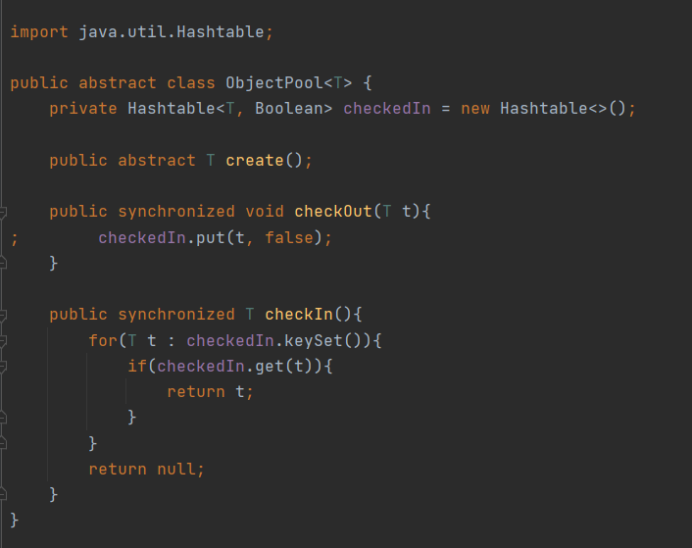

import java.util.Hashtable;

public abstract class ObjectPool<T> {

private Hashtable<T, Boolean> checkedIn = new Hashtable<>();

public abstract T create();

public synchronized void checkOut(T t){

; checkedIn.put(t, false);

}

public synchronized T checkIn(){

for(T t : checkedIn.keySet()){

if(checkedIn.get(t)){

return t;

}

}

return null;

}

}

And a RobotsPool class extending ObjectPool.

**RobotsPool.java**

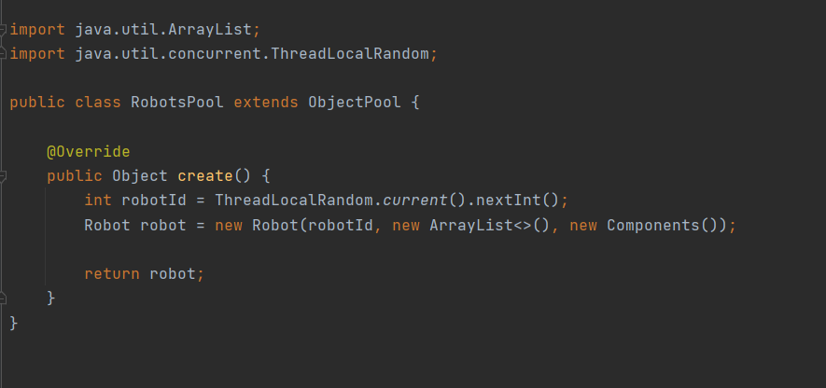

import java.util.ArrayList;

import java.util.concurrent.ThreadLocalRandom;

public class RobotsPool extends ObjectPool {

@Override

public Object create() {

int robotId = ThreadLocalRandom.current().nextInt();

Robot robot = new Robot(robotId, new ArrayList<>(), new Components());

return robot;

}

}

And let’s use the pool.

**App.java**

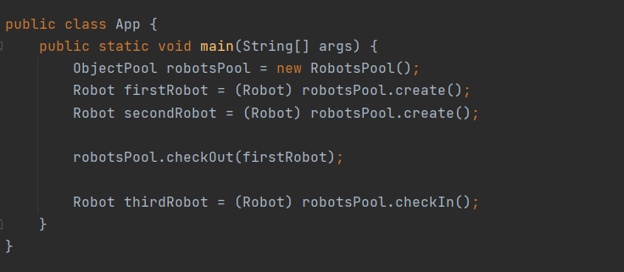

public class App {

public static void main(String[] args) {

ObjectPool robotsPool = new RobotsPool();

Robot firstRobot = (Robot) robotsPool.create();

Robot secondRobot = (Robot) robotsPool.create();

robotsPool.checkOut(firstRobot);

Robot thirdRobot = (Robot) robotsPool.checkIn();

}

}

**STRUCTURAL PATTERNS**



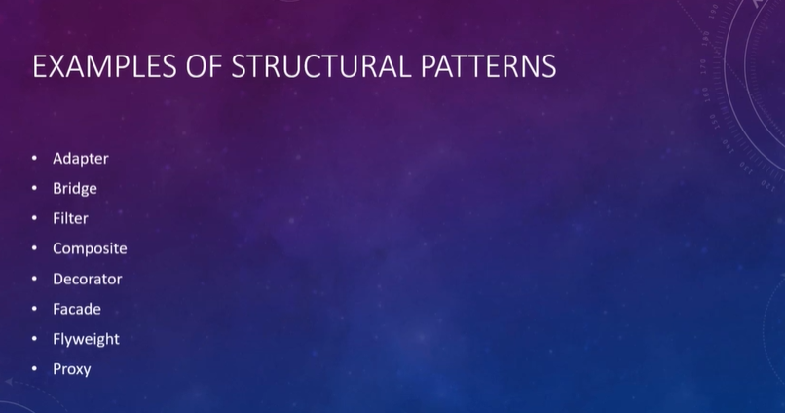

**THE ADAPTER PATTERN**





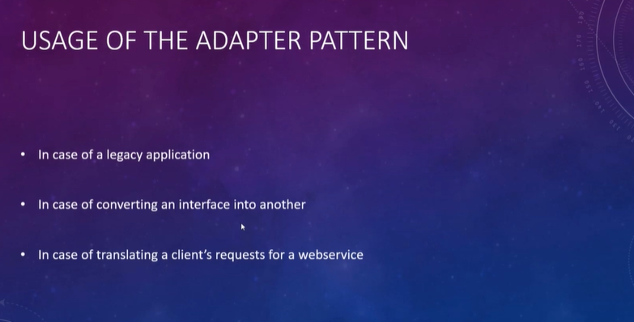



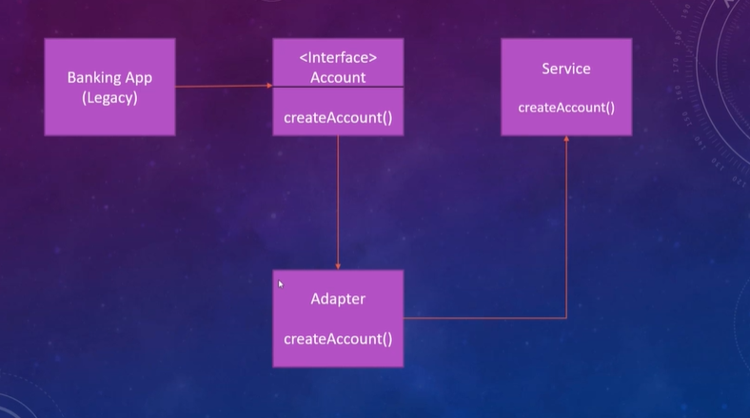

**THE BRIDGE PATTERN**



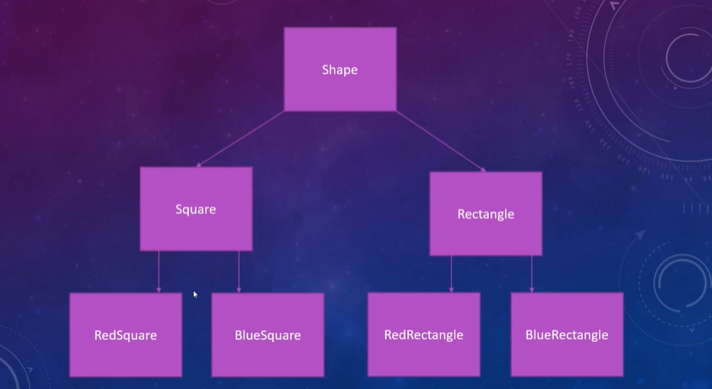

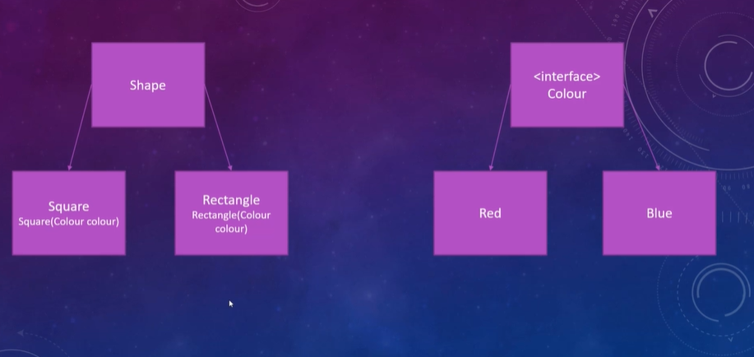

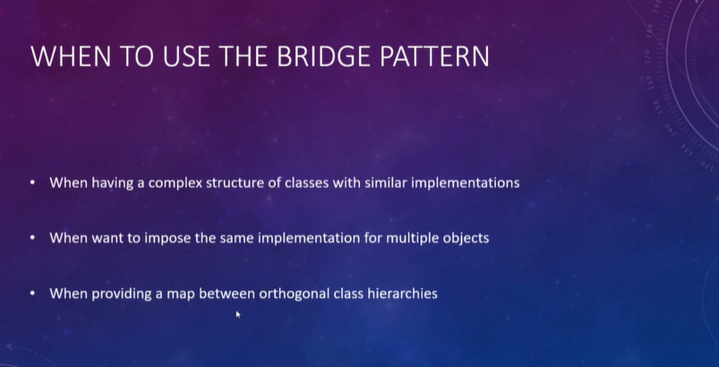

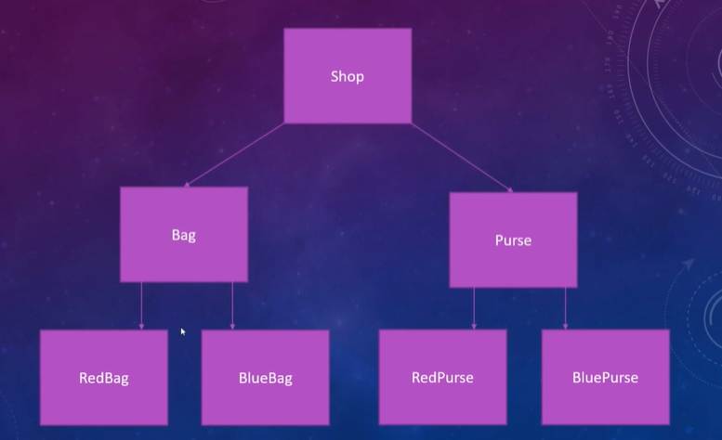

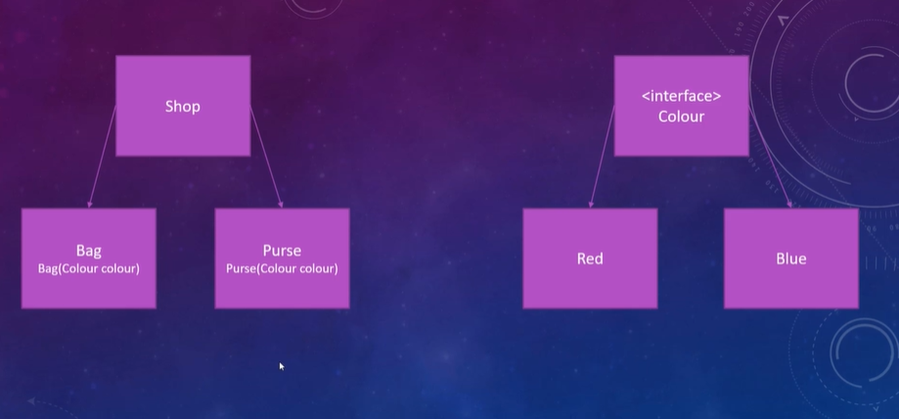

**THE FILTER PATTERN**



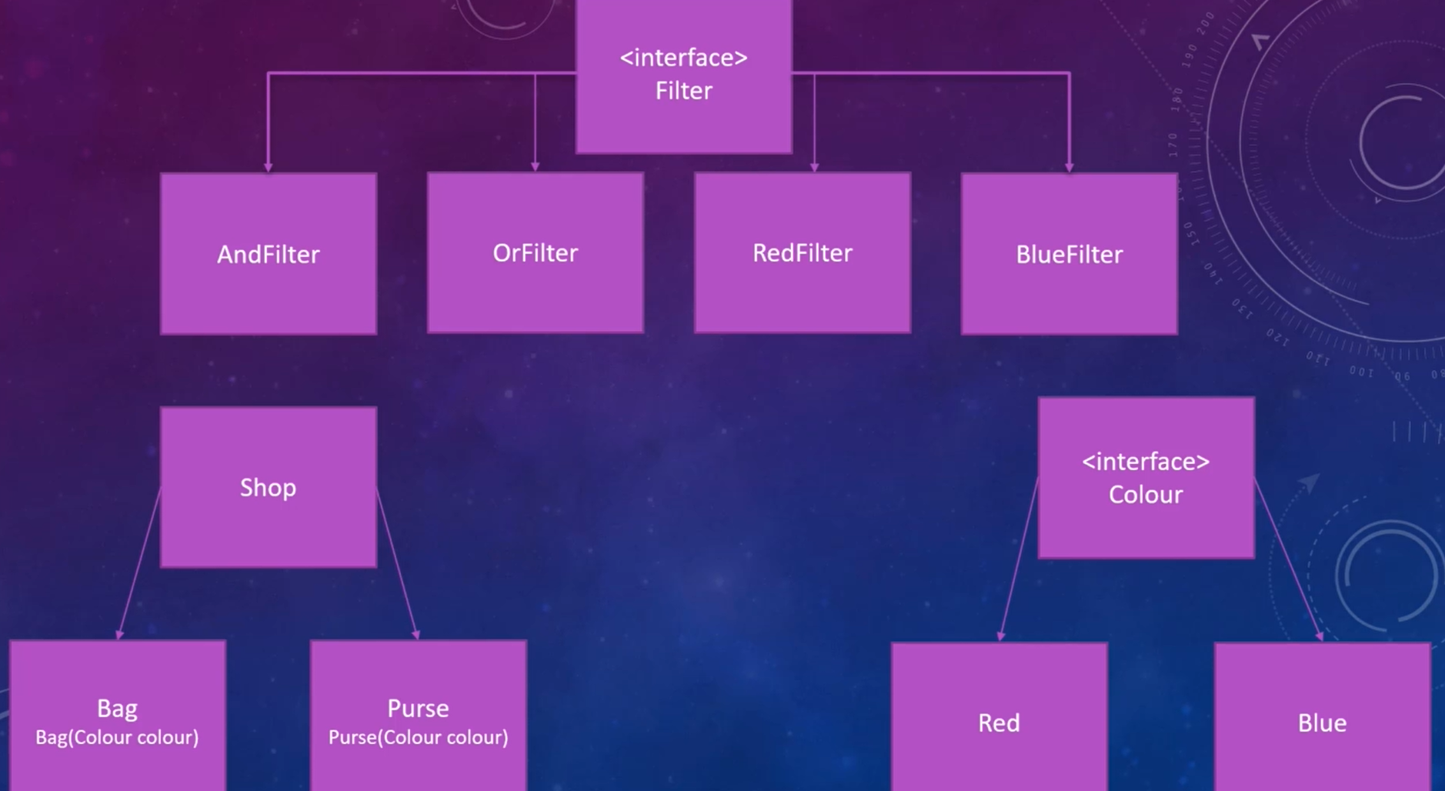

**THE COMPOSITE PATTERN**



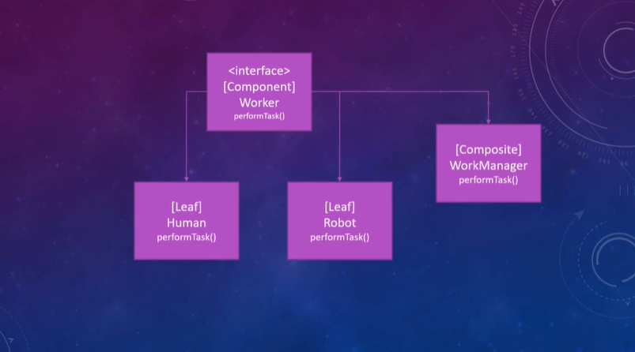

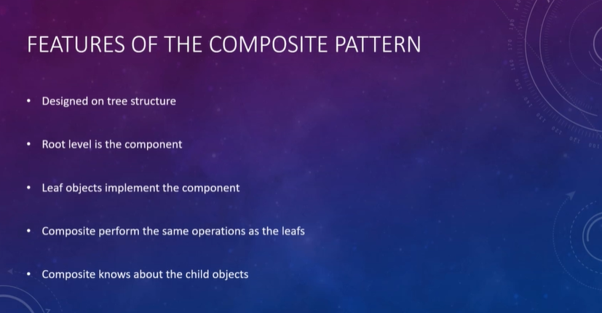

**THE DECORATOR PATTERN**



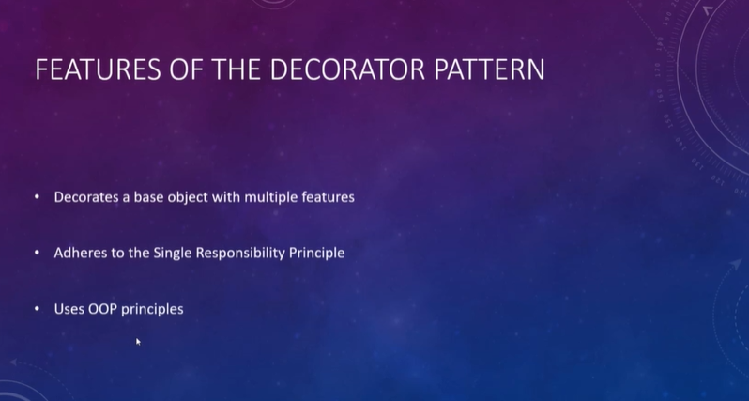

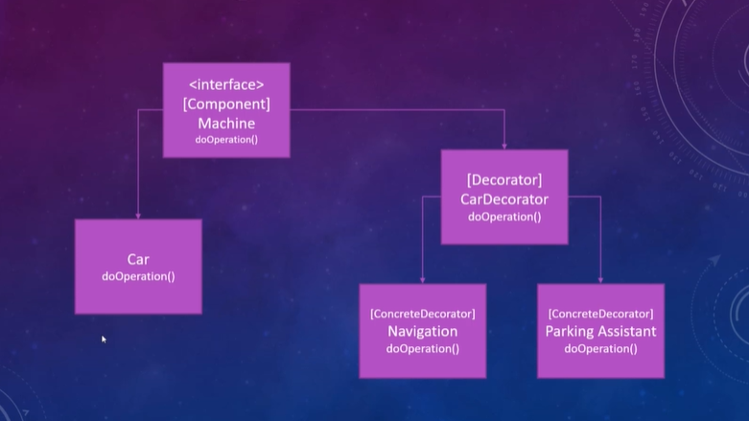

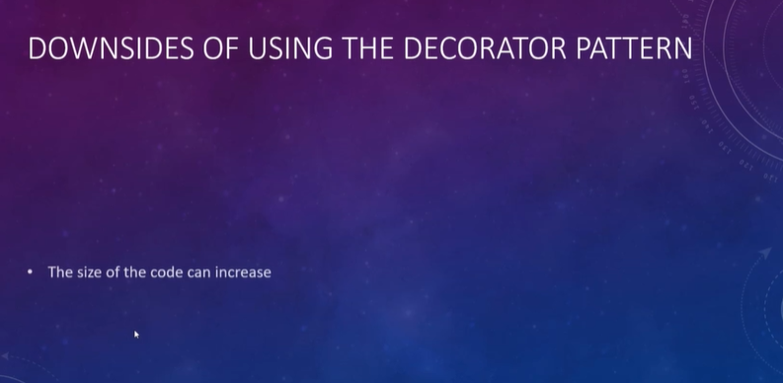

**THE FACADE PATTERN**



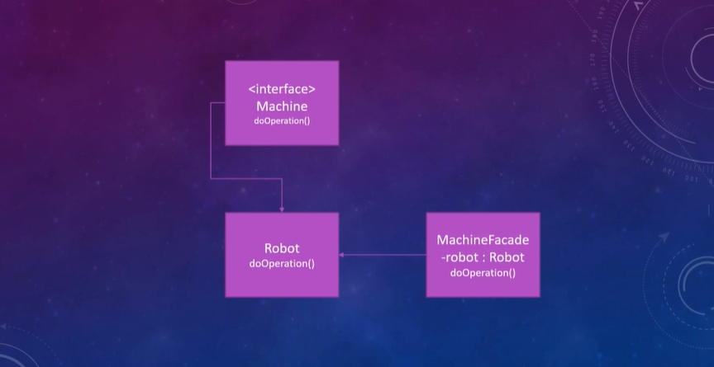

**THE FLYWEIGHT PATTERN**





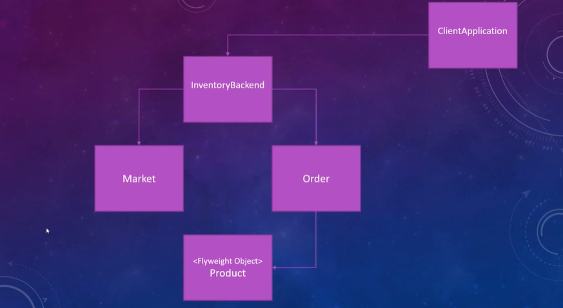



**THE PROXY PATTERN**





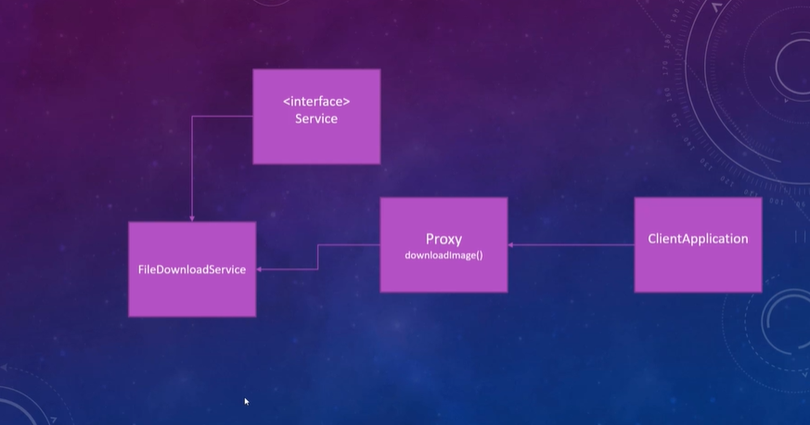



**Quiz**

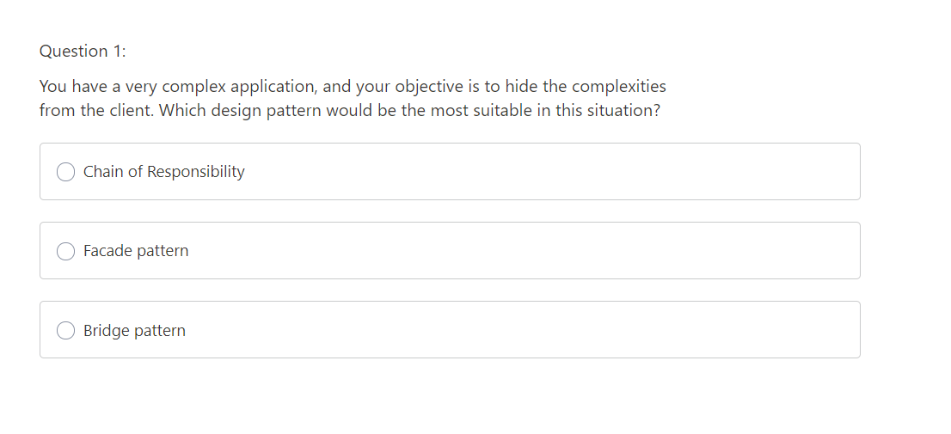

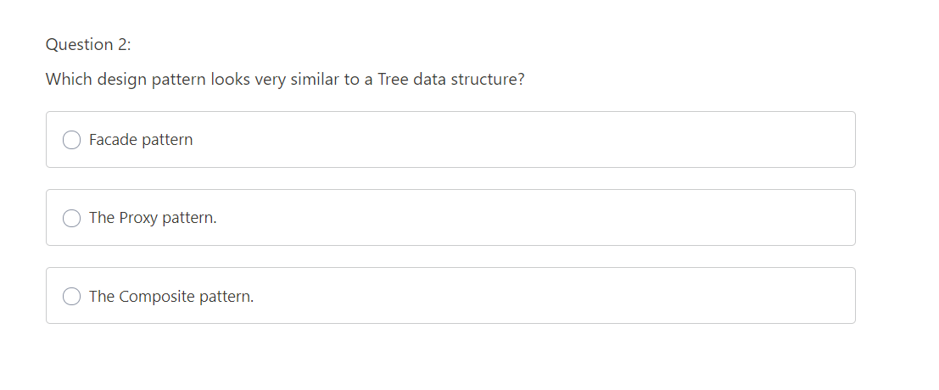

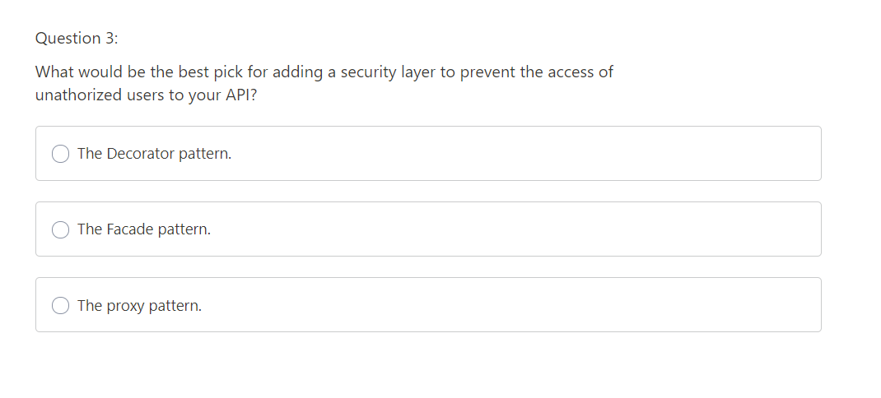

**BEHAVIOURAL PATTERNS**



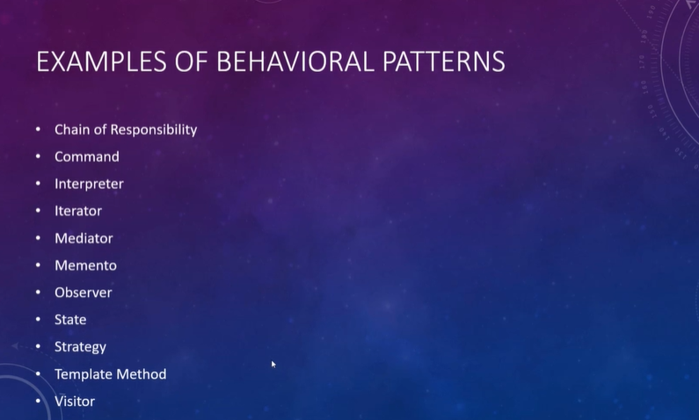

**THE CHAIN OF RESPONSIBILITY PATTERN**



